HW1 P3

b ) As shown in the picture below, there are total of 4 depth of possible solutions to guess the number from 1 to n if n = 15. The game can always be won in at most 4 guesses because there must be a solution within these 4 depths of options. Ex. starting with middle number. if first guess is 8, the answer must be either greater or smaller than 8. If the answer is smaller than 8, then the answer must be within 1- 7. If the answer is greater than 8, then the answer must be within 9 -15. In the next depth, guess the middle number again. Then the answer must be either greater than or smaller than the middle number. We will then able to move on to next depth, which has smaller numbers to guess. Eventually, after, at most 4 guesses(depth), the answer must be within the four depths.

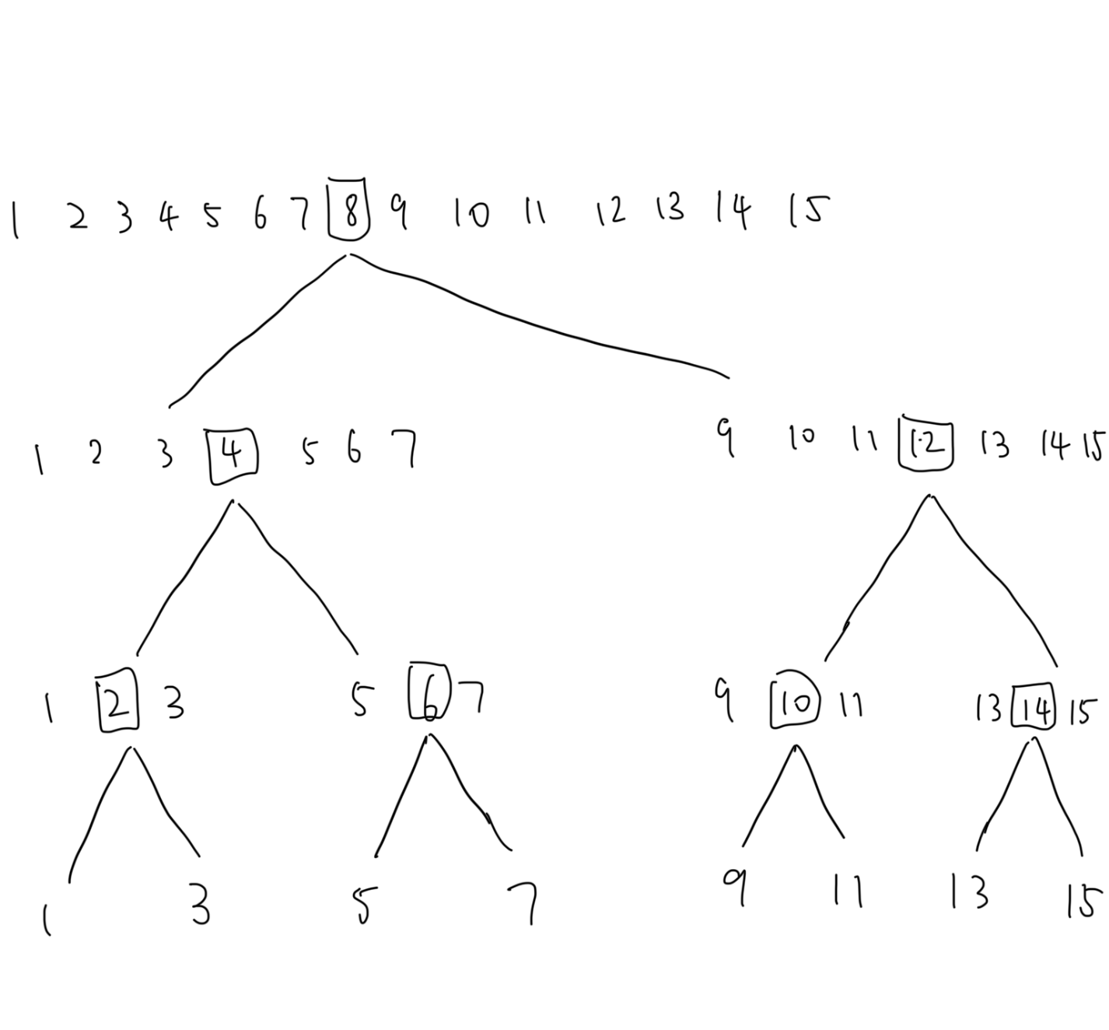

c)

T(n) = T(n/2) + 1

d)

